Sys.argv – os package

Information about sys.argv

Sys.argv is a module from python’s build in os library.

The import code is :

import sys

sys.argv generates a list of the arguments we pass into our cmd/terminal when we run our python programs.

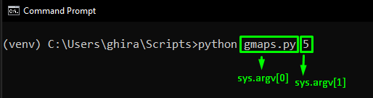

An example where we could use this is the following block of code :

# name of module sysargvtest.py

import sys  
  
def helloworld(number):  
 for x in range(int(number)):  
 print('Hello World')  
  
if __name__ == '__main__':  
 if len(sys.argv) == 2:  
 number = sys.argv[1]  
 helloworld(number)

In this block of code:

if len(sys.argv) == 2:  
 number = sys.argv[1]  
 helloworld(number)

We basically say if we write a second system argument then make the number is == to the sys.argv we type in , if we type python sysargvtest.py 3 it will run our helloworld function 3 times.

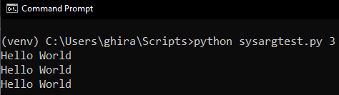

Our number variable is == to 3 in cmd prompt and our whole list of sysargv looks something like this:

[‘sysargvtest.py’, ‘3’]

Another cool example is by using google maps. We are going to make a little script that we can type directly into our terminal or cmd where the arguments we type is going to be the search part of google.maps.com

import sys, webbrowser, pyperclip  
  
if len(sys.argv) > 1:  
 # Get the address from the command line  
 address = '+'.join(sys.argv[1:])  
else:  
 # Get address from clipboard  
 address = pyperclip.paste()  
  
webbrowser.open(f'https://www.google.ro/maps/place/{address}')

pyperclip is an external library that takes the content of our clipboard (ctrl + v) and outputs it into a string.

So basically the code above does the following:

1. Checks if the length of our sys.argv is greater than 1, if it is then it joins them together deliminated by ‘+’.

This ‘+’join(sys.arg[1:]) does the following . Takes all the parts of our list starting from the 2nd index and joins them together deliminated by a plus sign.

1. If our sys.argv is less than 1 then address variable will be equal to the contents of our clipboard.
2. After it opens our webbrowser with our formatted string url containing address



The outcome:

